**LAB EXPERIMENT – 4**

**Perform Internet Footprinting Internet**

|  |  |
| --- | --- |
| **Type of Target** | **Information Obtained** |
| E.g. Website / Domain | * IP Address - 91.201.40.166 * Geolocation - Moskva - Moskva - Llc Ruweb * Hosted by - Private Person * Physical address - Russia * Services provided – Pirated Games * Server names - MILES.NS.CLOUDFLARE.COM   JOAN.NS.CLOUDFLARE.COM   * Server OS - Linux * Top Management - None |
| E.g. Person | * Name - Palak Singhla * Location – Himachal Pradesh * Phone – No Info * Office Address – CU, Chandigarh * Home Address - Solan, Himachal Pradesh * Role – Twitter Friend * Credit Card – No Info * Hobbies – Chatting and Gossips * Buying Habits – No Habits at all * Friends – Aditi, Shreya, Ananya * Social Media Posts 🡪 6 Pictures Captured * Twitter / Facebook - palak__016 |
|  |  |

Used Grabify and got the ip using social engineering on Instagram.

Link Used – <https://grabify.link>

Original URL - <https://www.upes.ac.in/>

Geo Location - <https://www.google.com/intl/en_in/earth/about/>

Website Information - https://whois.domaintools.com/rin.ru

**Target 1**

**Young Teen**

Source – Instagram

Method – Social Engineering

IP - 43.251.191.199

Coordinates - 28.666775, 77.216681 (28°40'0"N 77°13'0"E)

Geo Location – Delhi, India

ISP – Dnetworks Internet Services Pvt. Ltd.

Device – Real ME 7 Pro

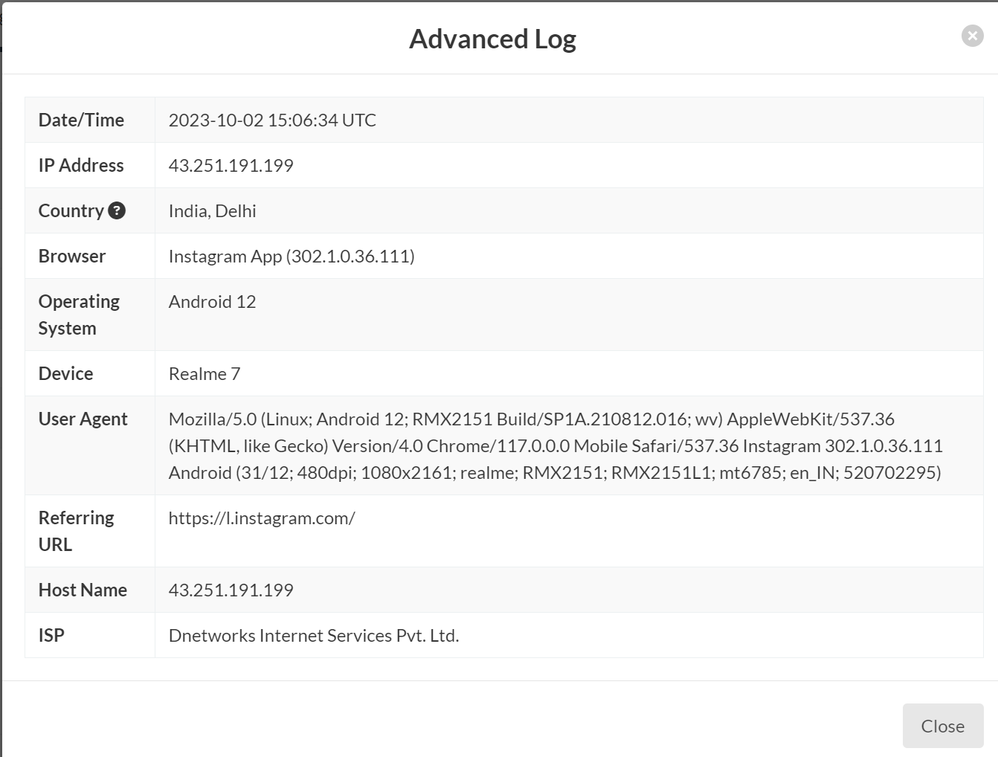

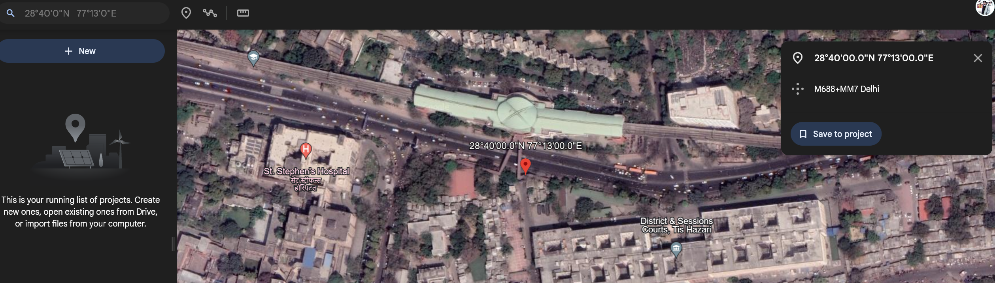

**Target 2**

**Student at CU**

Source – Instagram

Method – Social Engineering

IP - 103.41.26.231

Coordinates - 32.039330, 75.403180 (32°2'22"N   75°24'11"E)

Geo Location – Gurdaspur, Punjab, India

ISP – Fastway Transmission Private Limited

Device – Vivo Y20G (2021)

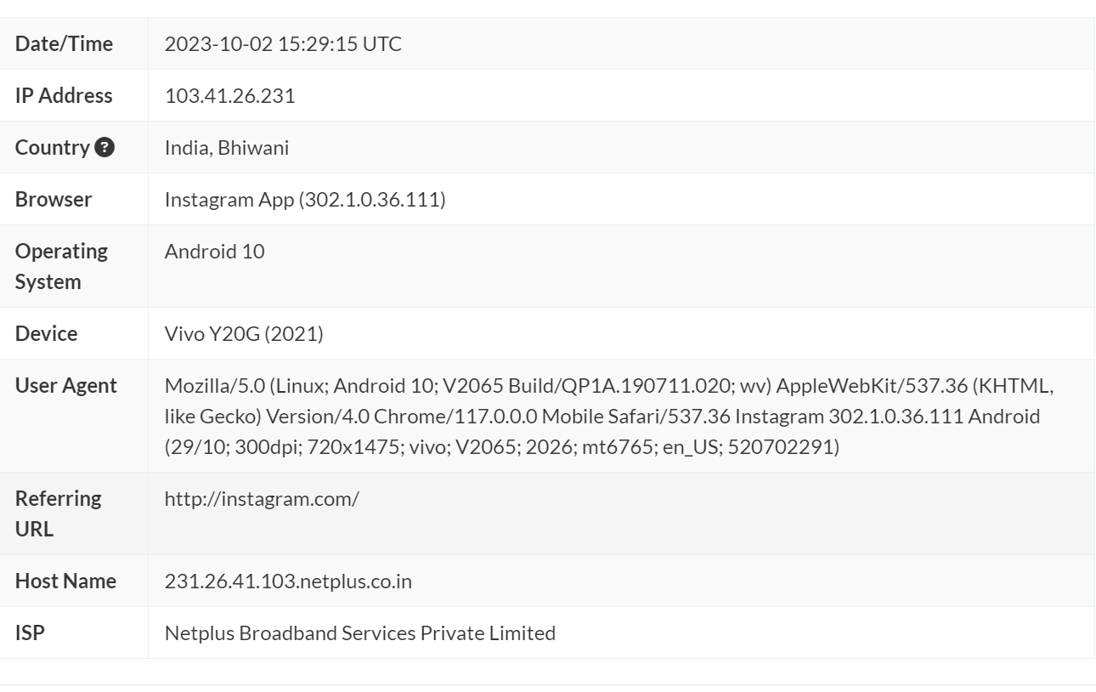

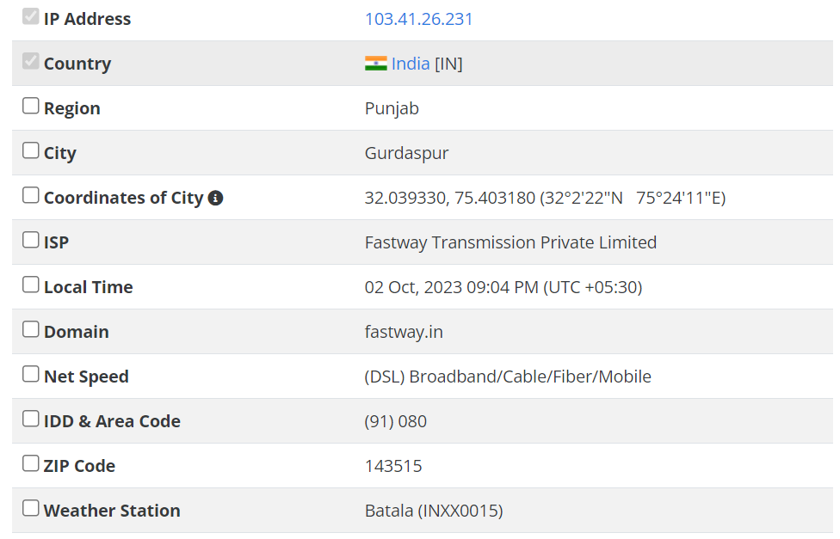

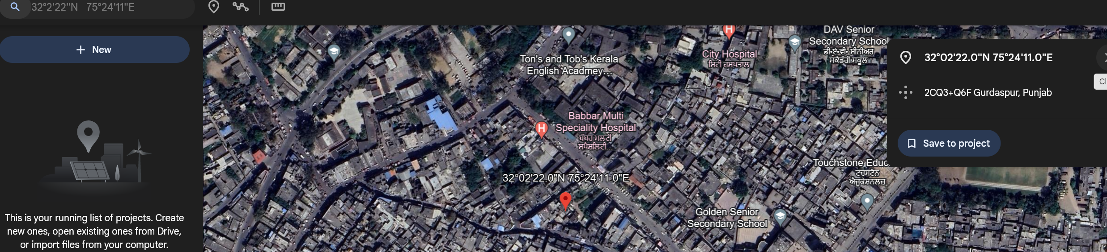

**Target 3**

**Student at CU’s Friend at Home**

Source – Instagram

Method – Social Engineering

IP - 223.187.100.126

Coordinates - 30.916670, 77.116670 (30°55'0"N 77°7'0"E)

Geo Location – Solan, Himachal Pradesh, India

ISP – Bharti Airtel Ltd.

Device – Apple iPhone (iOS 12.3.1)

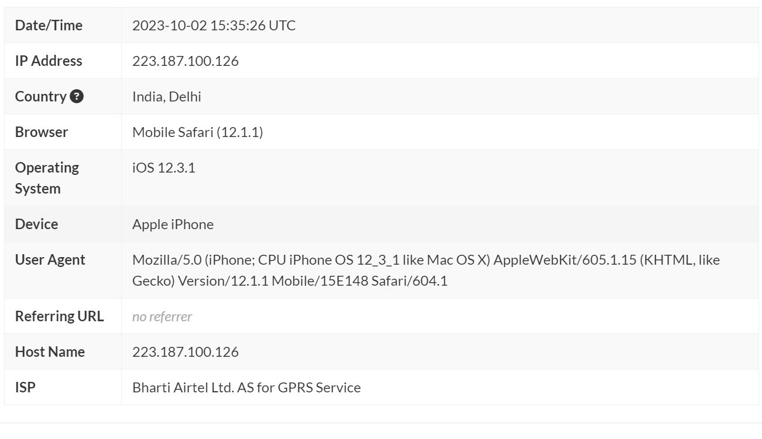

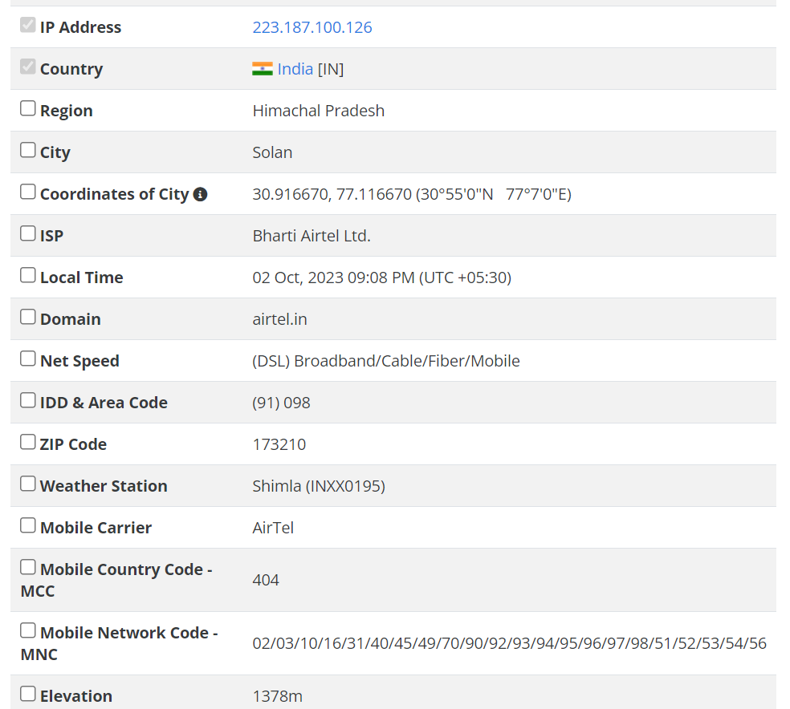

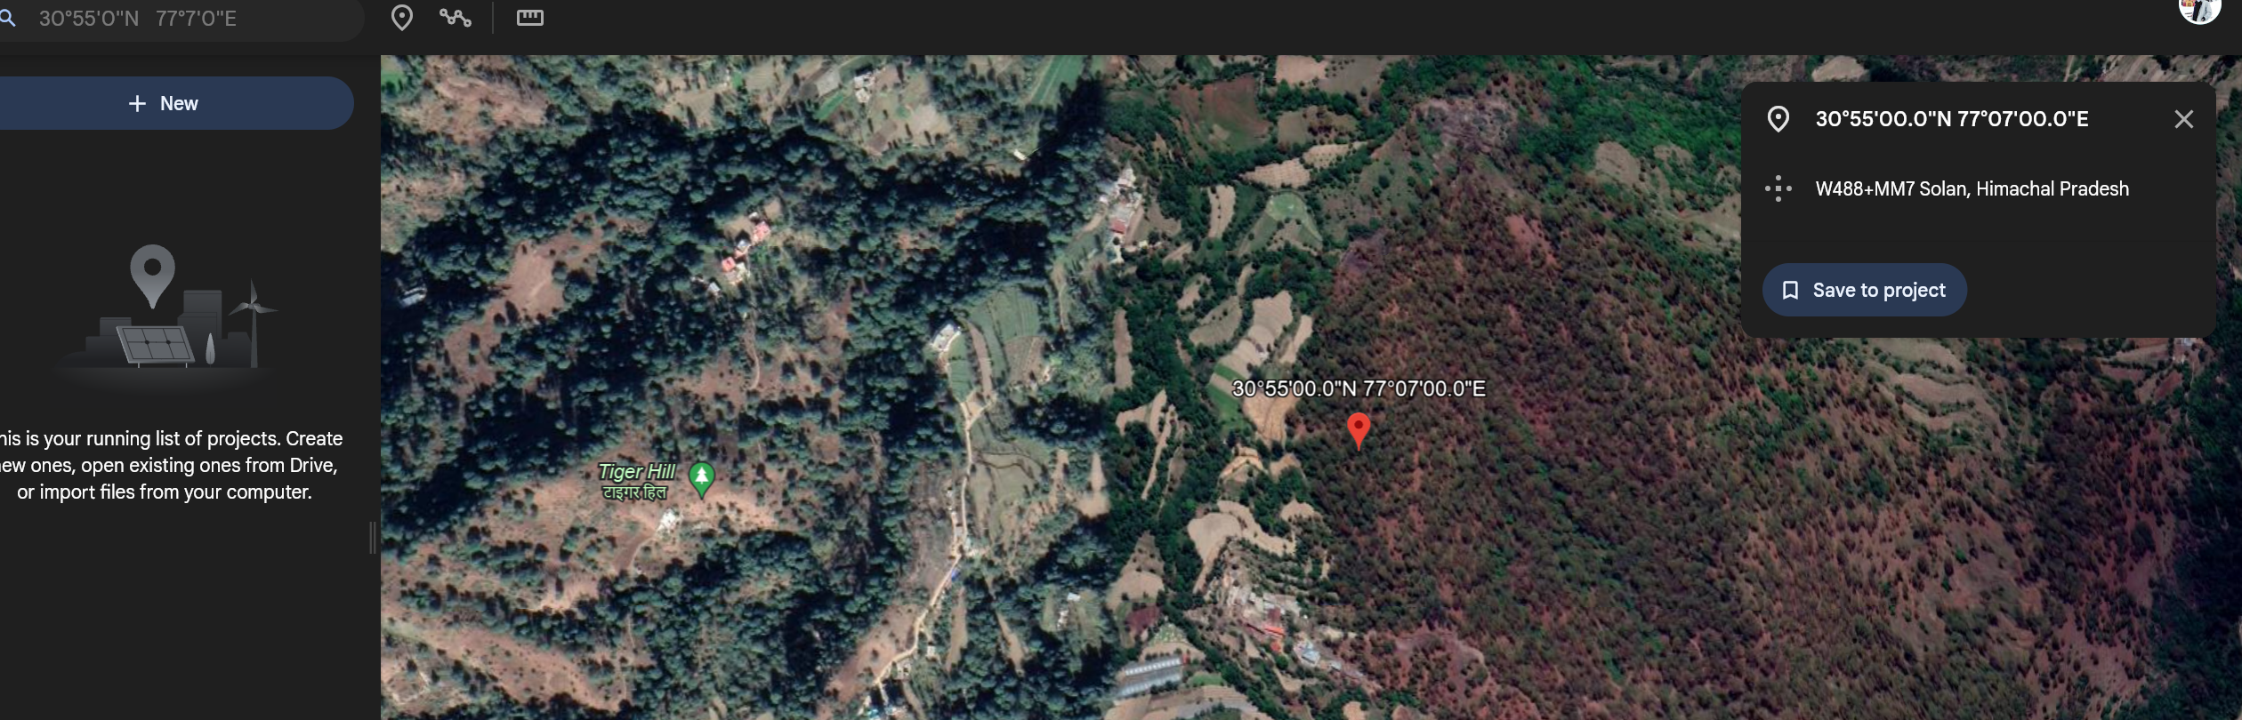

**Target – Website**

